
Name……………………………………………..
Fact or Fiction? Read the following statements about languages in Europe and decide if they are Fact or Fiction.
1. The national language of Austria is German ………………………………
2. There are 2 official languages in Finland: Finnish and Swedish ………………………………
3. There are 2 official languages in Belgium: Flemish and German ………………………………
4. There are 2 official languages in Luxembourg: French and German ………………………………
5. The main language spoken in Spain is Castilian ………………………………
6. Arabic, Chinese and Hindi are the main non-European languages most widely used on European territory ………………………………
7. In London around 200 languages are spoken ………………………………
8. Most of the official EU languages are Indo-European ………………………………
9. Russian is one of the official languages of the EU ………………………………
10. English is spoken by more than half the entire population of the EU ………………………………

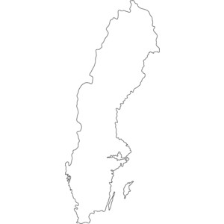
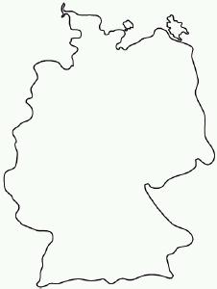
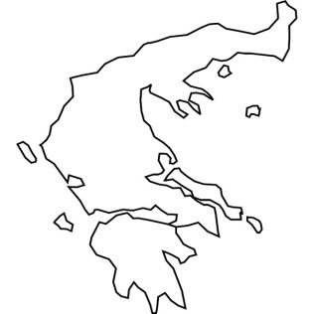
EU Member States Name the member state and its official language(s).
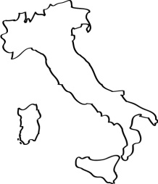
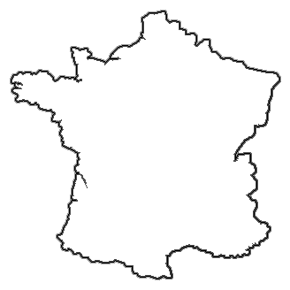
1………………………. 2………………………. 3………………………. 4………………………. 5……………………….
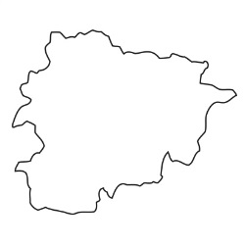
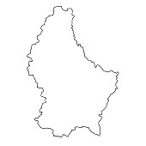
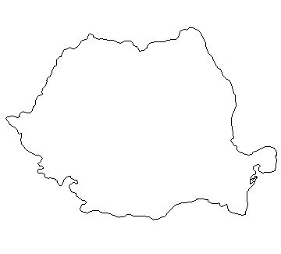
…………….…………. ……….………………. ………………….……. …………….………… ……………….……….

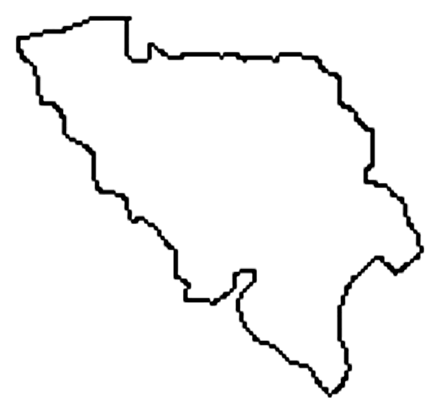

6………………………. 7………………………. 8………………………. 9………………………. 10……………………….
………….……………. …….…………………. ………………….……. …………………….…. ……………………..…..

